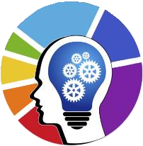

The Mind

building the future with mind…

**Project Completion Certificate**

Date: 29-04-2024

Place: Trichy

This is to certify that **Mr. Harish D.R** (**Reg.No:22304215**) final year **MCA** student of **VELS Institute of Science, Technology & Advanced Studies**, **Chennai** has been successfully completed his final semester project entitled **“Sign Tone: A Deep Learning-Based Deaf Companion System for Two Way Communication between Deaf and Non-Deaf Individuals”** in our organization under the external guidance of **Miss.N.Suryalakshmi** during the period from **January 2024** to **June 2024**.

Congratulations on completing this project successfully. May it be an important step towards achieving his full potential in life.

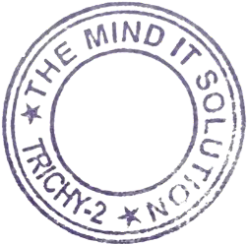

Sincerely,

# Project Coordinator

**The Mind IT**



# The Mind IT Solution

No.1, Ground Floor, Christ Church Complex, Chatram bus stand, Trichy, Tamil Nadu-620002. [www.themind.co.in,](http://www.themind.co.in/) [hr@themind.co.in,](mailto:hr@themind.co.in) 0431-3559737.